**DAILY ONLINE ACTIVITIES SUMMARY**

|  |  |  |  |  |  |  |  |  |
| --- | --- | --- | --- | --- | --- | --- | --- | --- |
| **Date:** | **8-06-2020** | | | | | **Name:** | **Sinchana** | |
| **Sem & Sec** | **6 B** | | | | | **USN:** | **4AL17CS117** | |
| **Online Test Summary** | | | | | | | | |
| **Subject** | | **CNSC** | | | | | | |
| **Max. Marks** | | **60** | | **Score** | | | **34** | |
| **Certification Course Summary** | | | | | | | | |
| **Course** | **Python programming** | | | | | | | |
| **Certificate Provider** | | | **E-box** | | **Duration** | | | **2 hours** |
| **Coding Challenges** | | | | | | | | |
| **Problem Statement: 1.palindrome 2.singly linked 3.difference of 2 square numbers** | | | | | | | | |
| **Status: Success** | | | | | | | | |
| **Uploaded the report in Github** | | | | | **Yes** | | | |
| **If yes Repository name** | | | | | **coding** | | | |
| **Uploaded the report in slack** | | | | | **Yes** | | | |

Online Test Details: (Attach the snapshot and briefly write the report for the same)

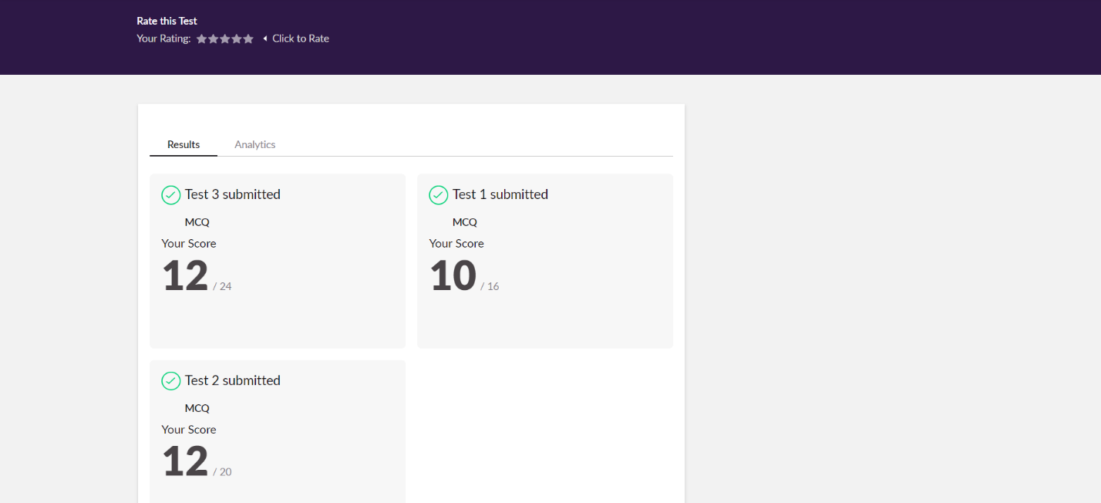

The test was held between 3:30 pm to 4:00 pm. It consisted of only 3 round and the total marks assigned was 60.The above snapshot is the output of my test.

Certification Course Details: (Attach the snapshot and briefly write the report for the same)

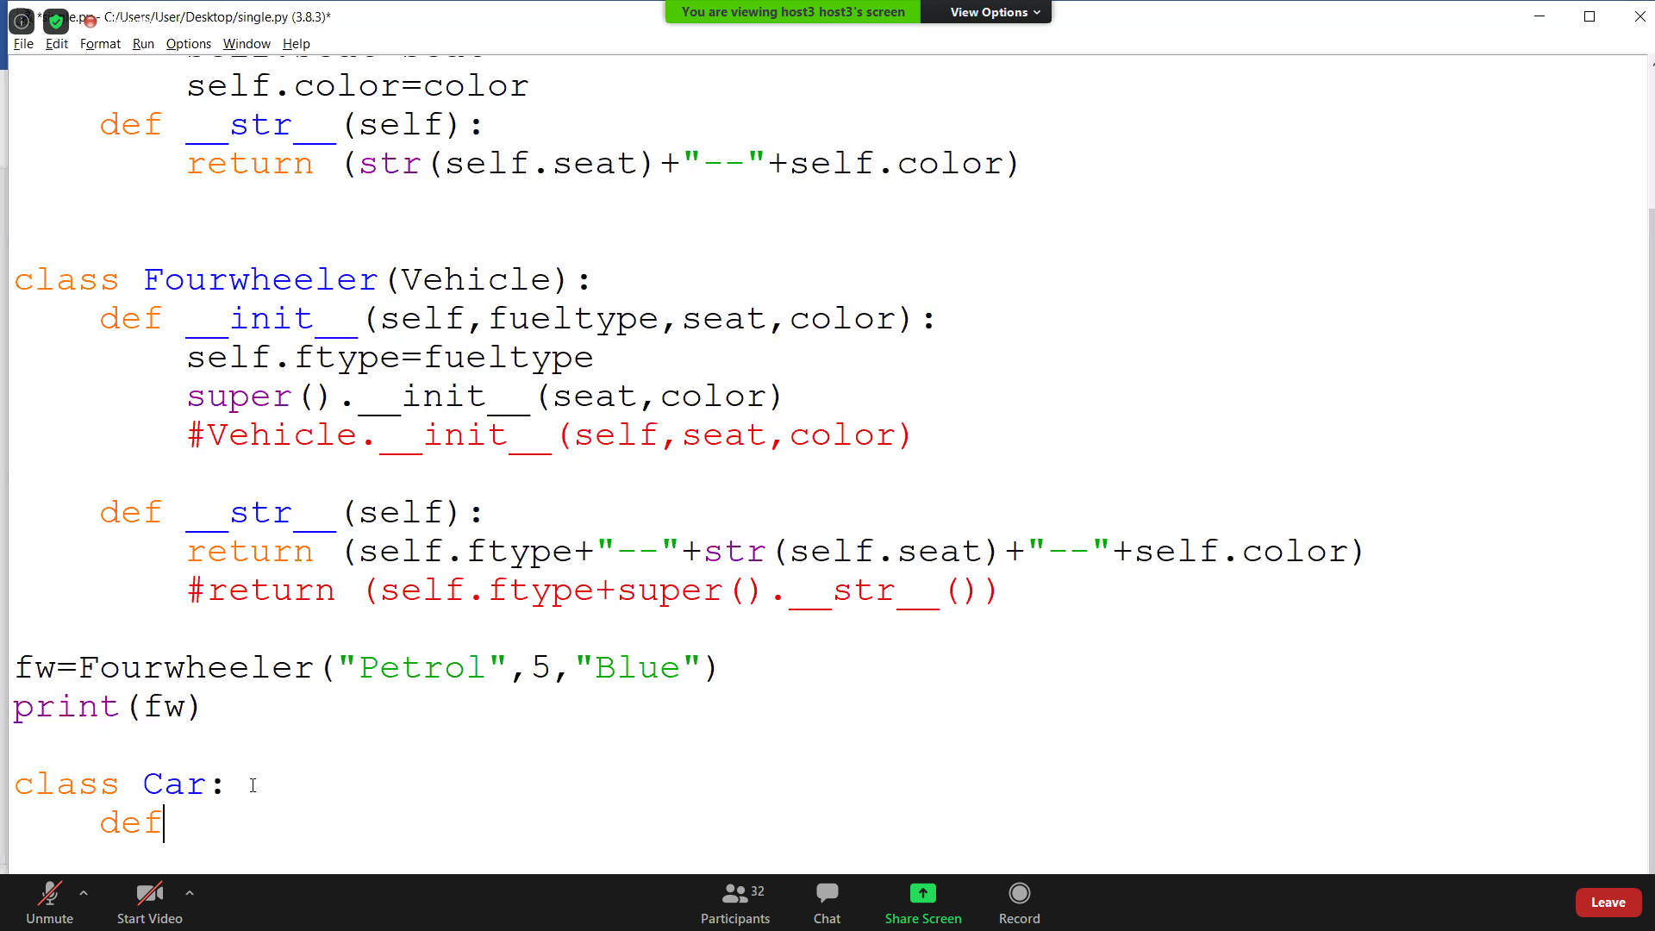

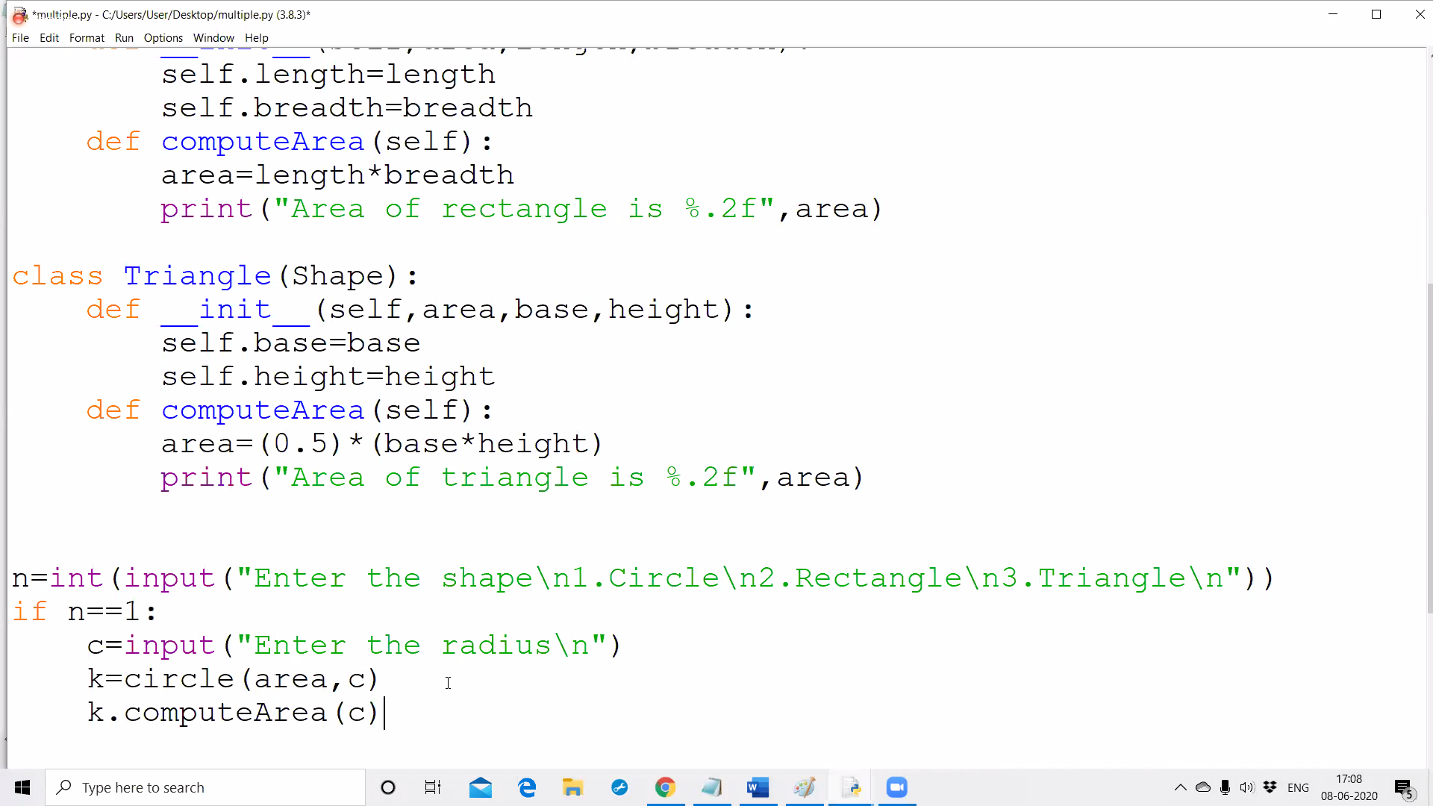

Today I have learnt about inheritance which defines a class and inherits all the methods and properties of another class and some of examples.

Coding Challenges Details: (Attach the snapshot and briefly write the report for the same)

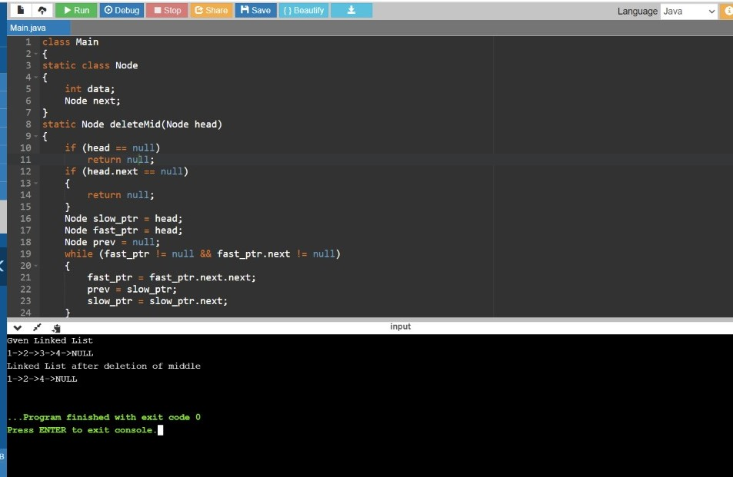

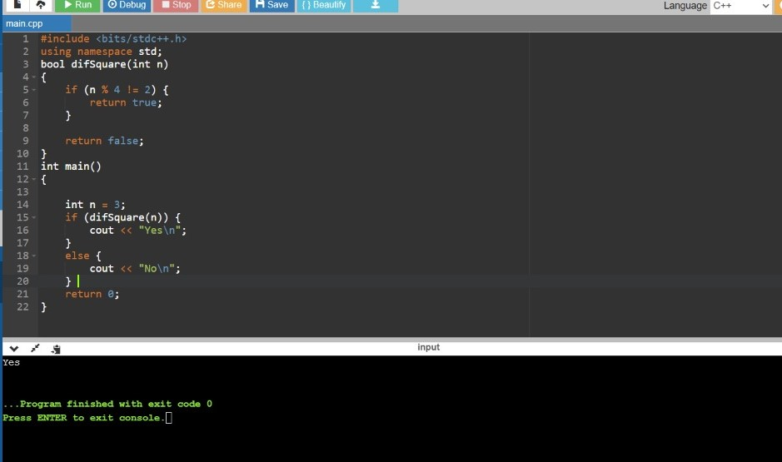

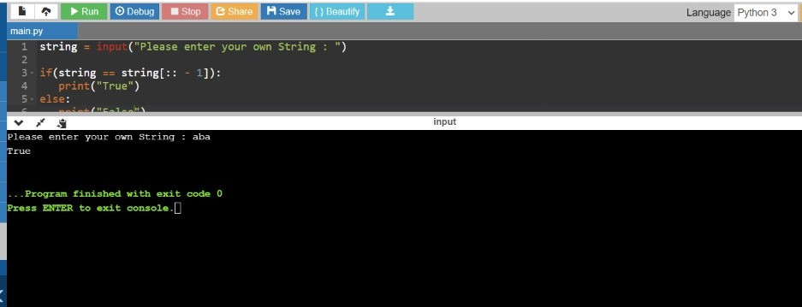

Link in GitHub : <https://github.com/sinchana514/coding>

<https://github.com/sinchana514/coding/tree/master/8th%20june>